**Ancient America**

**Land-bridge theory:** First humans came into North America over the now submerged land bridge in the Bering Strait about 14.000 years ago.

Detail:During ice age, the sea level was low, Bering Strait could walk through. Until 13000 years ago, ice melted, the sea level became higher, and the land-bridge disappeared.

**Vikings 1000AD:** Vikings made some landings on coast of North America, but settlements were soon abandoned. No written sources survived.

**Native Americans:** In 1491 about 50-70 million native Americans in both continents

Over 2000 languages spoken by countless tribes. Most advanced civilizations in Central and South America

**Iroquois Confederacy:** Military confederation

Nations of six Indian tribes: Mohawks, Oneidas, Onondagas, Cayugas, the Senecas, Tuscanona

Residence: Longhouse prominent building

**Pueblo Indians**: Live in Rio Grande Valley in New Mexico, Arizona, southwest Colorado

Environment: dry climate Agriculture: corn planting and irrigation systems

Residence: House: Multi-Storied Dwellings

**The Mound-Builder Mississippians:** Live in Mississippi and Ohio Valleys Biggest settlement: Cahokia

Agriculture: Settled Agriculture Residence: Mound-building

**The Plain Indians** (Cheyenne): Live in Present day S. Dakota, Nebraska, Kansas

Nomadic people who dependent on Buffalo Residence: Tee-Pees

**The Aztecs:** Live in Present-day central Mexico Capital: Tenochtitlan

Tribute Empire War Culture Human Sacrifice

(**Corn** for the Mayas and Aztecs and **potatoes** for the Incas)

Not until the 17th century did American Indians **acquire horses** from Spanish settlers. With horses, tribes could more easily follow buffalo herds.

**Colonial period**

**European Exploration of the America**

**1.Changes in Thought and Technology:** The invention of Gunpowder, Caravel, Compass and and Printing press

**2.Religious Conflict:**

Reconquista: Catholic Victory in Spain against Muslims after Spanish unification of Castille and Aragon

Reformation: Split of the Christian Church in Catholics and Protestants.

Protestants: Belief in God and sincere lifestyle needed. Break away from the church.

They considered America as place for religious freedom and chance to spread religion

**3.Expanding trade:** After Fall of Constantinople in 1453 *land route for trade with the Far East blocked off*

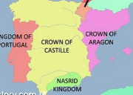Henry the Navigator explored coast of West-Africa 1498 Vasco Da Gama reaches India by sailing around Africa

**4.Developing Nation-states:** Small Kingdoms turned into Nation States

Example: Castile + Aragon > Spain New kingdoms needed wealth to continue their rule

**Treaty of Tordesillas**: 1494 Pope Alexander VI divides the Americas 'Inter Catera west for Spain, East for Portugal

**English** claimed lands explored by John Cabot on **east coast of North America**

Jamestown first colony established by Sir Walter Raleigh

**French** claimed lands in **north and the center of North America** explored by Jacques Cartier.

**Primary sources**: provide direct evidence of a topic.

**Secondary sources**: the analyses based on existing primary source.

For example, if one were researching the American Civil War, the primary source would be a letter written by a soldier who fought in the war, while a secondary source would be a history book about the war.

**1521 – Hernan Cortes conquers Tenochtitlan**

(Montezuma decided to ambush the Spanish troops, where Cortes had learned about it. In November 1519, Cortes took control of Tenochtitlan and took Montezuma Hostage. He then stopped human sacrifice. Because of the fighting among allies and Aztecs broke-out, Cortes was forced to retreat. By the time Cortes had returned to Tenochtitlan 11 months later, smallpox had killed most of the Aztec population. In June 1521, the Spanish destroyed the Aztec capital.)

**Encomienda:** to entrust

Theory: A conquistador, Encomenderos was granted land and would protect, care for and Christianize Native Americans in exchange for labor.

Practice: Encomenderos abuse the system and Native Americans die from diseases, harsh conditions and forced labor and aren't allowed to leave

**Great Dying**: Because of conquest, diseases and slavery, massive dying of Native Americans (The disease called small pots is the major factor that caused the Great Dying)

**Asiento:** (Mainly foreign) merchants pay money to the Spanish crown for the right to import African slaves into Spanish America

**Caste system:** (Casta: lineage) Birth and lineage decide position in New Spain society. Caused Strict division based on bloodline

**Mestizo:** mixed blood person

**Conquistadors:** Spanish conquerors of the Americas after 1492, responsible for the death of countless Native Americans

**Moctezuma:** The Aztec King that was captured by Hernan Cartez in 1520 during the conquest of the Aztec empire

**Quetzalcoatl:** A white god of the Aztecs. The Aztecs mistook Cortes to be him as there was a legend that the Quetzalcoatl would return to the Aztecs and end the human sacrifice.

**Noche Triste:** The night when Hernán Cortés was defeated by the Aztecs

**Malinchista:** traitor

(1501, Spanish queen Elizabith: if it’s Spanish territory, then the people live in there are Spanish.)

**New Spain 1600:** Covers huge areas of Central and South America

Gradually a mixed society that included Native Americans and Africans

**New France 1609:** *Samuel de Champlain* "Father of New France" claims Quebec

Mostly men for fur(beaver) trading, married Native Americans.

*1673* - Mississippi River explored by *Jolliet* and *Jacques Marquette*

Named territory Louisiana after *Louis XIV*. New Orleans trading center

**New Netherlands1609**: established on the Hudson River, claimed by *Henry Hudson*, a British explorer who paid by the Dutch. Dutch bought Manhattan from the Indians for f24.

Small colonies along the coast, less intermarrying with Native Americans.

**New England:**

**1496 Grant Henry VII to John Cabot:** Grant to discover what wasn't discovered by Portuguese or Spanish yet

*Giovanni Caboto* came upon Newfoundland, thought he had discovered East Asia

**England 1500-1600:** Internal strife, Reformation, break with Catholicism, Church of England

**Surplus population**: Population growing faster than economy, more poor people

Question: Give two reasons why England didn't establish colonies in America around1500.

Answer: In the 1500s, England's efforts to establish colonies in America were feeble for two main reasons. First, England was initially allied with the powerful Spanish Empire and showed little interest in competing with Spain in overseas colonization. Second, England experienced religious conflicts, including the struggle between Catholics and Protestants, which began after King Henry VIII's split from the Roman Catholic Church in the 1530s. These religious disputes consumed resources and disrupted England's ability to focus on overseas colonization.

Under Elizabeth I (1558-1604) stronger England, conflict with Spain (Due to Religion, interests, and Spanish financing of the Irish rebellion).

**Defeat Spanish Armada 1588**

Question: How did the Spanish Armada play a role as a turning point in Spanish imperial dominance?

Answer: The defeat of the Spanish Armada by the English navy in 1588 marked a significant turning point in Spanish imperial dominance. It weakened Spain's naval power and disrupted its control over the seas. This defeat allowed other European powers, including England, to challenge Spain's dominance and expand their own colonial ambitions.

**1584 Lost Colony Roanoke Island**

*Sir Walter Raleigh* started a colony on Roanoke Island off the coast of present-day North Carolina, called the area Virginia after 'Virgin Queen'

Colony mysteriously disappeared, food shortage and conflict with Native Americans

**1604 - Peace England & Spain:** Treaty of London ends war between Spain and England

(Spain ceased its involvement in the Irish insurrection, and the British renounced marauding on the high seas)

**England after 1600:**

**Laws of primogeniture** only allow oldest sons to inherit landed estates.

**These are the motivations of England’s colonize**

Unemployment, thirst for adventure, religious freedom, new markets

1606 *King James I* issues **First Charter of Virginia**

Question: Why is the charter of the Virginia Company an important document in American History?

Answer: The charter of the Virginia Company, issued by King James I in 1606, granted the company the right to establish settlements in the New World. This charter is significant because it provided the legal framework for the establishment of Jamestown, one of the first permanent English settlements in North America.

Question: What was the role of **joint-stock companies** in English colonization?

Answer: Joint-stock companies were instrumental in financing early English colonization efforts. These companies allowed investors to pool their resources and share the risks associated with colonization. The Virginia Company, for example, was a joint-stock company that funded the Jamestown settlement in Virginia.

Types of Colonies:

**Corporate colonies** by joint-stock companies

**Royal colonies** directly under the king

**Proprietary colonies**, individuals with charters of ownership from the king.

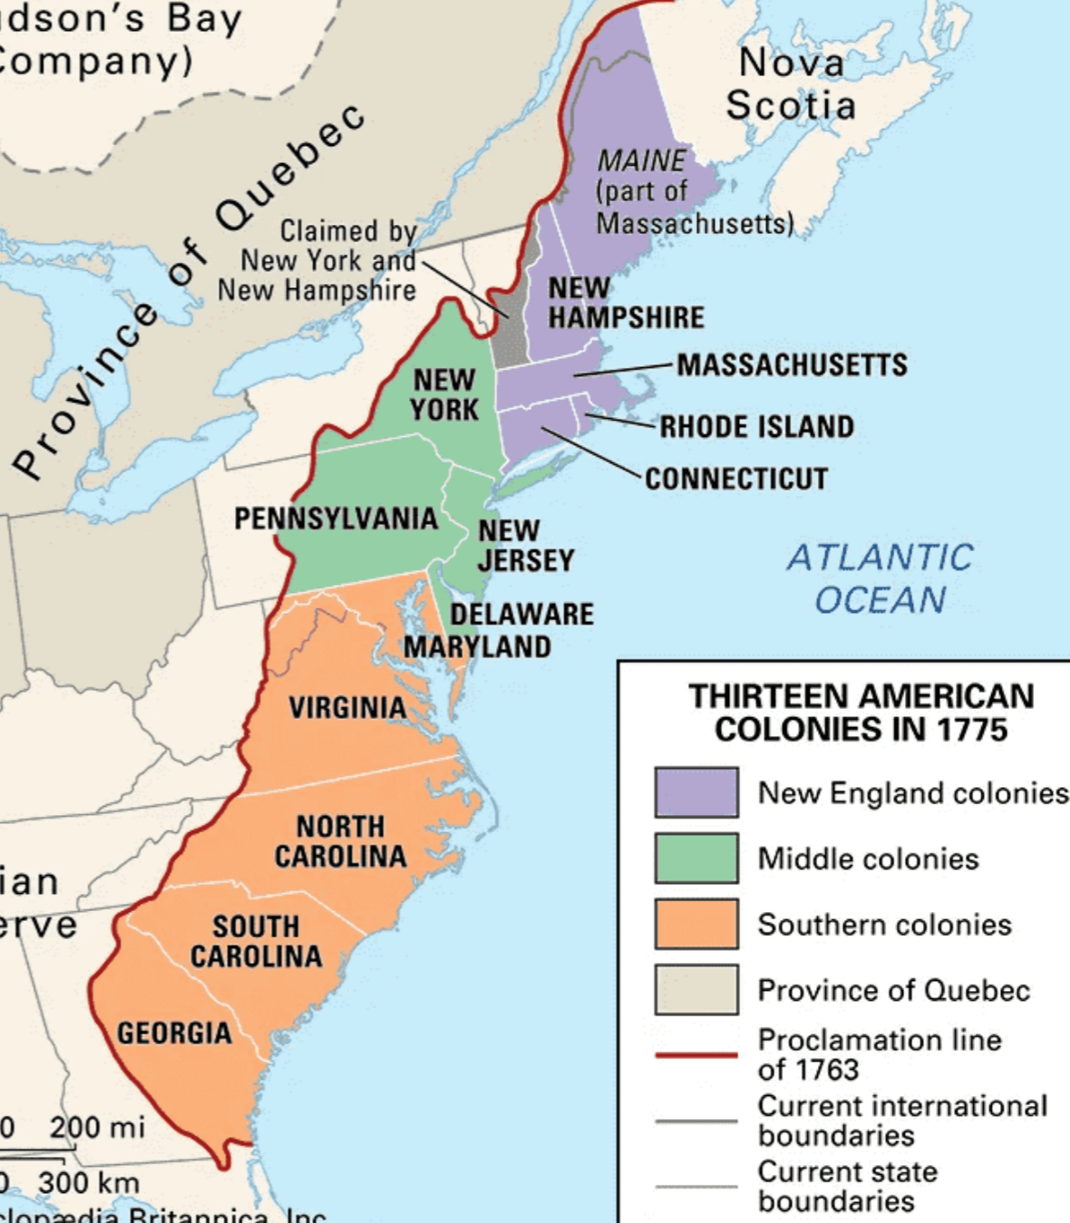

**Jamestown** (Virginia): Corporate colony changed to **Royal colony**

England's *King James I* chartered the Virginia Company, a joint-stock company that founded the first permanent English colony in America at Jamestown in 1607.

Troubled years of Jamestown as a corporate colony 1607~1624, leadership of John Smith

1624- Further, the Virginia Company was nearly bankrupt, the king took direct control

Change to Royal Colony despite success Tobacco plantations

**Headright system** - 50 acres for settler that pays for a new settler

**Plymouth 1620: Royal colony**

Separatists’ settlers from Church of England under *William Bradford* called **Pilgrims** for their long travels aboard **Mayflower**

**Mayflower Compact** - Document for Self-governance (allow to make laws)

**Thanksgiving** 1621 - Survival thanks to help Indians

Merged with Massachusetts in 1691 to royal colony

Question: Explain what different motives for migration did people aboard the Mayflower have in TWO sentences.

Answer: People aboard the Mayflower had different motives for migration. Some were Separatists seeking religious freedom, while others had economic motives for making the voyage, such as the pursuit of economic opportunities in the New World.

**Massachusetts Bay** 1630:

Moderate dissenters **Puritans** under leadership of John Winthrop wanted to purify Church of England, persecuted by king Charles I

**Great Migration**: Religious and political conflict in England in the 1630s drove 15,000 settlers to the Massachusetts Bay

**Economy** based on small towns and family farms that relied on a blend of commerce and agriculture.

Merged with Plymouth in 1691

**Maryland** 1632:

Split off from Virginia, safe haven for Catholics under *George Calvert*

**Act of Toleration 1649** - Freedom of Religion (Christians only)

Question: Explain what the Act of Toleration from 1649 meant in ONE sentence.

Answer: The Act of Toleration from 1649 meant that it was the first colonial statute granting religious freedom to all Christians in Maryland.

Economy and society much like Virginia, **indentured servants** (Get a free trip and must work for 4 years without salary)

**Protestant Revolt** 1688 against Catholics: Protestants won, repealed the Act of Toleration. Catholics lost the right to vote.

**Rhode Island** 1644 (Providence+ Portsmouth=R.I.)

*Roger Williams* believed in individual's conscience

Banished by Puritans, found Providence for **Baptists** and with freedom of worship for all people.

Recognized rights of American Indians

Small colonies get charter together in 1644: Providence (establish by William) + Portsmouth

**Connecticut** 1665

*Thomas Hooker* found Hartford with group of Puritans in 1636

**Fundamental Orders of Connecticut** 1639(the first written constitution in American history): Representative Government chosen by popular vote.

Connecticut was established as a Royal Colony in 1665 when Hartford (1636) and New Haven (1637) settlements united

**New Hampshire** 1679

Cut off from Massachusetts Bay Colony

*John Cutt* first president of New Hampshire

English king Charles II hoped to increase control over the colonies, made N.H a **royal colony**.

**Pennsylvania 1681**

*William Penn*, asylum for **Quakers**, completely against violence

Well planned, advertising in Europe(promised political, religious freedom and generous land terms) land bought from Indians

Fertile soil and navigable rivers, grain export, "**bread colonies**”

**Frame of Government 1682 and Charter of Liberties 1701**: Freedom of worship

**New York** 1664

*King Charles II* granted his brother *James Duke of York* to conquer **New Amsterdam** from the Dutch governor *Peter Stuyvesant* (N.Y. separate England’s colonies)

Renamed to **New York**, new taxes, duties, and rents with no assembly. Resistance from settlers

Dutch people allowed to stay with freedom of worship and use of Dutch language

**Carolina** 1663

Granted to eight nobles after helping the king Charles II in war

1729 split into **North Carolina** and **South Carolina**

**South Carolina** 1729**:**

Economy initially based on fur trading. Later rice-growing plantations, worked by enslaved Africans

**North Carolina** 1729

No good harbors and poor transportation.

Small, self-sufficient tobacco farms.

Reputation for democratic views and autonomy from British control

**Georgia** 1732

Defensive buffer against Spanish

Florida under leadership of *James Oglethorpe*

Place to dump prisoners in debt, ban on drinking and slavery

**Royal colony** in 1752, Spanish threat hindered growth, plantations afterwards

**New England:**

North, rocky soil, Puritans, town meetings

**Middle colonies:**

Fertile soil, bread colonies, diversity, navigable rivers, representative assemblies

**Southern Colonies:**

Tobacco and rice plantations, slavery

Question: Give a geographical reason and a religious reason why most slave ships would rather go to South Carolina than to Pennsylvania.

Answer: The first reason is the geographical factors: South Carolina was in a more favorable location for the slave trade due to its proximity to the Caribbean and other southern colonies. The climate and agricultural conditions in South Carolina were well-suited for large-scale plantation agriculture, which required a significant labor force, making it a lucrative destination for enslaved Africans. Pennsylvania, located in the northern part of the American colonies, had a climate and agricultural landscape less conducive to large-scale plantation agriculture. (Pennsylvania's terrain is more hilly and rugged, limiting the availability of flat, arable land for large plantations. South Carolina has more flat land.)

The Second reason is the religious factors: South Carolina had fewer religious and moral objections to slavery, as the institution was deeply integrated into its social and economic systems. Pennsylvania, especially in its Quaker communities, had a stronger anti-slavery sentiment, making it a less appealing destination for slave traders.

|  |  |  |  |  |
| --- | --- | --- | --- | --- |
| **Colony** | **Year** | **Type** | **Important person** | **Religion** |
| Virginia | 1607 | Corporate→Royal | John Smith | Anglicanism |
| Plymouth | 1620 | Proprietary(not certain)→Royal | Willim Bradford | Puritanism |
| Massachusetts Bay | 1630 | Corporate→Royal | John Winthrop | Puritanism |
| Maryland | 1632 | Proprietary | George Calver | Christianity |
| Rhode Island | 1644 | Proprietary (not certain) | Roger Williams | Freedom of religion |
| Connecticut | 1665 | Royal | Thomas Hooker | Puritanism |
| New Hampshire | 1679 | Royal | John Cutt | Puritanism |
| Pennsylvania | 1681 | Proprietary | William Penn | Quakers |
| New York | 1664 | proprietary | Duke of York | Christianity(Major Catholic) |
| Carolina | 1663 | Proprietary | Eight nobles |  |
| South Carolina | 1729 | royal colony | - |  |
| North Carolina | 1729 | royal colony | - |  |
| Geogia | 1732 | Royal | James Oglethorpe | Orthodox Christianity |

**Protestantism** **Anglicanism**: Church of England

**Puritanism** (separatist): Separate from Church of England.

**Baptists**: Against infant baptism, give freedom of religion

**Christianity** **Antinomianism**: Formed by *Anne Hutchinson*. Since individuals receive salvation through their faith alone, they were not required to follow traditional moral laws

**Quakers**: believed that religious authority was found within each person, not in the Bible nor in any outside source

**Catholicism:** pope be the head of the church

Question: Explain in TWO sentences why Separatists came to be known as Pilgrims

Answer: Separatists came to be known as Pilgrims because they sought to organize a completely separate church that was independent of royal control. They became known as *Pilgrims due to their journey in search of religious freedom*.

God created man on the seventh day, and Adam and Eve lived in the **Garden of Eden**. They were tempted by a snake and ate the Tree of the knowledge of good and evil, which was forbidden. Leading to **The Fall**, they were banished from Eden. The relationship between man and God was destroyed.

Later, God made **Ten commandments** to repair the relationship, but humans did not obey the commandments and the relationship repair failed.

Then God sent his Son **Jesus** to earth, and if people believe in Jesus, they can repair their relationship with God through him and enter heaven

**Catholicism:** People connect with the Pope through the church and then with Jesus and finally with God

**Emphasis symbol**

**Protestantism:** Connect directly with God through faith in Jesus

Too much Catholicism left in Anglican Church, Separatists

Focus on a very strict interpretation of the Bible as only source of authority

Belief in predestination, only **salvation** through faith

Personal Conversion experience very important

**Simplicity** important, no symbols like in Catholic Church

**Salvation**: the act of being saved from sin and its consequences, and receiving eternal life through faith in Jesus Christ

(Fixed the line/ relationship with the God, and can go to the heaven)

**Halfway Covenant** 1662: In Puritanism only 'full rights' for somebody that had a personal ‘conversion' experience

Partial membership offered to people without 'conversion' to maintain church influence

Seen as a threat by strict Puritans, no longer a congregation of 'True Believers'

Question: Explain why strict Puritans didn’t like the Halfway Covenant in TWO sentences

Answer: Strict Puritans didn't like the Halfway Covenant because it allowed people to become partial members of a Puritan congregation even if they had not experienced a confirmed religious conversion. This practice weakened the strict Puritan practices in order to maintain church membership, which went against their religious beliefs.

**Quakers**: They believed that religious authority was found within each person and not in the Bible nor in any outside source. This led them to support equality among all men and women and to **reject violence** and resist military service. Because their beliefs challenged authority, the Quakers of England were persecuted and jailed for their beliefs.

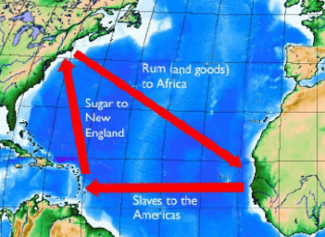

**Triangular Trade**: Transatlantic Trade between Europe, West Africa, and America

From Africa: Slaves, gold, ivory

From Americas: Rum, Furs, Rice

From Europe: Manufactured Goods & Luxuries

**Royal African Company**: Founded in 1660 by later *king James II*

Monopoly on trade in West Africa

First mainly gold, later slaves; Competition with Dutch slave traders

Monopoly ended in 1672 to fulfil plantations' need

**Mercantilism**: Economic theory that a country's wealth is determined by exports exceeding imports

Hence, governments tried to promote the sales of goods to other countries and to discourage purchases through tariffs

Colony should enrich the mother country.

**Tariffs**: Tax on imported goods

**Navigation Acts** 1651-1673:

1.Trade to and from the colonies only by English/colonial ships with English/colonial crews

2.Goods imported into the colonies, had to pass through ports in England.

3."Enumerated” goods(ex: Tabacco) from the colonies could be exported to England only.

**Salutary Neglect**: Weak enforcement of the laws

1. Distance: Atlantic Ocean separated the British government from the colonies,

2. Problems in England: Between 1642 and 1763, it was in constant turmoil. Went through English Civil War, a revolution that replaced the monarch, and four wars with France.

3. Corruption/Bribery: colonial merchants could evade regulations easily with well-placed bribes to those in charge of enforcing regulations.

**King James Il's Retaliation**

New *king James II* (believe **Catholicism**)1684 **Revoked Charter** of Massachusetts Bay Colony due to Smuggling Activity and minting coins without the king's

**Caused:** Resentment from Colonies and increased smuggling of goods into New England

**“Dominion of New England"** 1685-1688

*Sir Edmond Andros* served as the governor Levies high taxes,

Limits town meetings,

Revokes land & titles

Resistance in England and colonies against policy and Catholic religion James II

Invitation letter to William of Orange: the people are dissatisfied with the present conduct of the government and be desirous of a change

**Glorious Revolution 1688**

Disposition of *King James II*, Replaced by Dutch stadtholder *William of Orange* & *Mary* (support **Protestantism**

End of Dominion of New England

*Sir Edmond Andros* arrested by colonists; Salutary neglect continued